2014/7/22
Ver3.13.0

Kyocera USB Modem Driver
[kc02us_setup_x64.msi/kc02us_setup_x86.msi installer]

Installation/Uninstallation Procedure

Contents
1. Supported OS
2. Supported devices
3. Before Installation
4. Installation Procedure
5. Uninstallation Procedure
6. Attention

*The messages described in this manual are based on WINDOWS 7 x64 SP1.
Therefore, the messages may be not coincident with some devices.

Supported OS
Supported OS are as follows.
- Windows XP 32bit
- Windows Vista 32bit/64bit
- Windows 7 32bit/64bit
- Windows 8 32bit/64bit

Supported devices
Supported devices are as follows.
Kyocera devices.

Before Installation
If your PC is installed AntiVirus Software, please stop the service temporarily,
because installation may fail.

If you already installed the old USB drivers for Kyocera devices
(See “2. Supported devices”), please uninstall them as follows.

- Disconnect the handset from USB port on the PC.
- Select “Start” button of Windows.
- Select Control panel.
- Select “Add or Remove Programs”.
- Select “KYOCERA USB Modem SYxx Driver”, “KYOCERA ADB SYxx Driver”, “KYOCERA NDIS SYxx Driver”, “KYOCERA USB Modem KC01 Driver” or “KYOCERA USB Modem KC02US Driver”.
- Click “Remove” Button.
- Restart PC after uninstallation.
- If two or more old USB drivers were installed, please uninstall them all.

Installation Procedure

  - Disconnect the handset from USB port on the PC.
  - If your PC is 32bit OS, press kc02us_setup_x86.msi.
If your PC is 64bit OS, press kc02us_setup_x64.msi.
  - Install Driver dialog will be launched, and then press [Next] button.

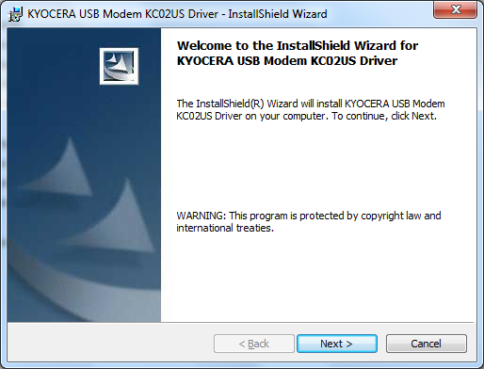

  - Press [Install] button.

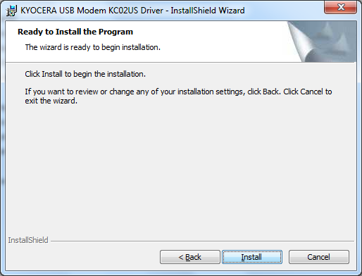

  - Installation is completed when the dialog "InstallShield Wizard Completed" is displayed.
Press [Finish] button to continue procedure.

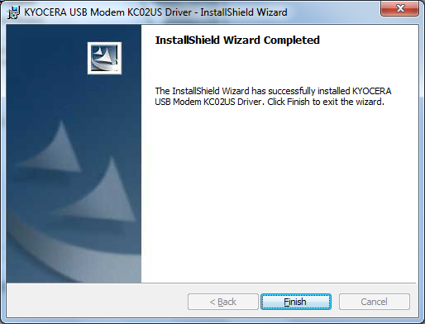

  - Connect the handset to USB port on the PC.
The handset will be recognized automatically by plug-and-play.

  - Installation is now completed.

*Confirm if the driver is working properly by Device Manager.
Press "Control panel"/"System"/"Hardware"/"Device Manager".

Uninstallation Procedure

- Disconnect the handset from USB port on the PC.
- Uninstall Driver
Press "Control Panel"/"Add or Remove Programs"
If either "Kyocera USB Modem KC02US Driver" exists, press [Change/Remove].

- Press [Yes] button when "Uninstall Driver" dialog is displayed.

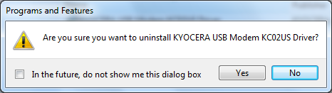

- When uninstallation is completed, the message to restart PC will be displayed, then press [Yes] button.
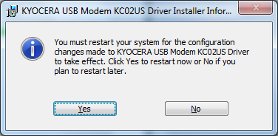

*NOTE: Please restart PC after uninstallation. Error could occur if driver is reinstalled without restart. Restart only once after all the drivers are uninstalled if few drivers need to be uninstalled.

Uninstallation is now completed.

Attention

*Please disconnect the handset from USB port on the PC before execute Installation/Uninstallation procedure.
Error could occur, if handset is connected to USB port.

*COM port number may vary depending on the handset.
The more increase the handset, the COM port is occupied as well.
If the COM port number is exceeded, please uninstall the unnecessary
drivers to release the COM port.

*If you use RNDIS driver by using Windows XP, please apply Service Pack 3.

